Virtual Campus Tour System

by

Yuxiao Long
(2330026110)
Yuxuan Liu
(2330026105)

A Final Year Project-I Partial Thesis
submitted in partial fulfillment of the requirements
for the degree of
Bachelor of Science (Honours)
in
Computer Science and Technology
at
BEIJING NORMAL-HONG KONG BAPTIST UNIVERSITY

May, 2026

ABSTRACT

Indoor virtual tour systems require reliable spatial reconstruction, but indoor environments often create challenges for image-based reconstruction due to repeated textures, weak visual features, reflective surfaces, and limited GPS availability. This project proposes a multimodal pipeline for constructing an indoor virtual campus tour using smartphone videos, checkpoint photographs, WiFi scans, and IMU data. The system processes WiFi scans to generate fingerprint features and uses IMU linear acceleration, rotation vectors, and movement events to estimate a relative pedestrian dead reckoning trajectory. Checkpoint photographs are strongly associated with WiFi/PDR points, while route video frames are extracted as weakly constrained visual bridge frames for COLMAP reconstruction. The pipeline exports image manifests, camera pose seeds, WiFi fingerprint libraries, signal boundaries, constrained COLMAP matching pairs, and PDR alignment references. A KNN-based WiFi localization model is also produced for estimating positions from new WiFi scans. By combining visual reconstruction with wireless signal features and inertial motion metadata, the project improves the organization of indoor image data and reduces the risk of incorrect matching in repetitive spaces. The final system provides a reproducible workflow from raw mobile data collection to dense point cloud generation and indoor localization support, forming a technical foundation for a virtual campus tour application.

Contents
ABSTRACT 1
1 Front pages 3
2 Main Text 4
2.1 Flow chat 4
2.2 Subsections 5
2.2.1 System Design and Methodology 5
2.2.2 Implementation, Outputs, and Evaluation 6
3 Fonts and Format and Binding 10
4 Conclusion 11
References 12

1 Front pages
The front pages of this thesis provide the formal information required for the Final Year Project submission. The title page identifies the project title, student names, degree programme, institution, and submission date. The declaration page states that the work is original except for properly cited references and software tools. The acceptance page is reserved for supervisor and observer signatures. The acknowledgement page recognizes academic guidance, technical support, and the contribution of open-source tools and research communities.
The abstract summarizes the motivation, objectives, methodology, expected results, and contribution of the project. The table of contents lists the major sections of the partial thesis and provides a clear structure for the reader. In the final submitted Word document, page numbering, figure numbering, and table numbering should follow the department template.

2 Main Text
Project Background
A virtual campus tour system should allow users to understand indoor spaces in a more spatial and interactive way than ordinary photos or maps. For outdoor mapping, GPS can provide approximate location information. However, GPS is unreliable or unavailable in indoor environments such as classrooms, corridors, libraries, and laboratory buildings. Indoor spaces also contain many repeated visual patterns, including similar doors, walls, floors, chairs, and corridors. These repeated structures make pure image-based reconstruction more difficult because visually similar but physically different areas may be incorrectly matched.
This project addresses the problem by combining three categories of smartphone data: visual data, wireless signal data, and inertial motion data. Checkpoint photographs and route videos provide the visual input for COLMAP-based reconstruction. WiFi scans provide indoor signal fingerprints that can be used for localization. IMU measurements provide acceleration and orientation readings that can be processed into a relative pedestrian dead reckoning path. The project does not treat WiFi and IMU data as direct 3D geometry. Instead, they are used as supporting spatial metadata for image organization, matching constraints, rough pose seeds, and localization.

2.1 Flow chat
For all the diagrams, there should be a caption below the diagram. All diagrams are given an index so that it can be referenced in the thesis. [2] [3]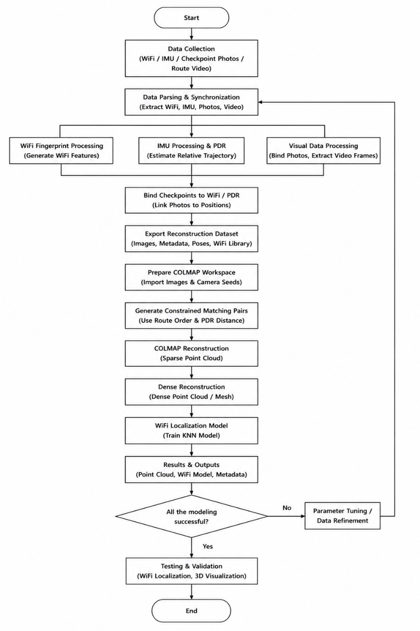
Figure 1: Chart

2.2 Subsections

2.2.1 System Design and Methodology
The proposed system is organized as an end-to-end pipeline. The input data consists of a smartphone session folder, checkpoint photographs, and route videos. The session folder stores WiFi scans, IMU sensor readings, and movement events. The checkpoint photographs are captured at WiFi points, while route videos are recorded continuously while moving between checkpoints.
The system separates the data into two complementary streams. The visual stream contains checkpoint photographs and extracted video frames. These images are used by COLMAP for sparse and dense 3D reconstruction. The signal and motion stream contains WiFi scans, IMU measurements, and movement events. These data are processed into WiFi fingerprints, PDR coordinates, route ordering, and matching constraints.

2.2.2 Implementation, Outputs, and Evaluation
The project implementation is modular. Each script is responsible for one part of the pipeline, which makes the system easier to test, debug, and extend.
File | Role
main.py | Launcher for the complete preprocessing pipeline
preprocess_pipeline.py | Main orchestration for WiFi parsing, IMU/PDR processing, image binding, video extraction, export, and COLMAP workspace preparation
image_mapping.py | Binds checkpoint photographs to WiFi/PDR points
video_frames.py | Extracts and filters route video frames
reconstruction_export.py | Exports COLMAP-friendly reconstruction datasets and metadata
wifi_positioning.py | Builds WiFi localization model, signal grid, and boundary data
localize_wifi.py | Estimates position from a new WiFi scan
colmap_bridge.py | Prepares COLMAP workspace, constrained match pairs, scripts, and metadata
run_colmap.py | Runs generated COLMAP batch scripts from the project root
The default preprocessing command is:
python main.py

The recommended COLMAP execution sequence is:
python run_colmap.py reset
python run_colmap.py sparse
python run_colmap.py dense

The final dense point cloud is expected at:
colmap_workspace/dense/fused.ply

The expected final deliverables include:
A working preprocessing pipeline from raw phone session data to COLMAP-ready images and metadata.
A processed IMU/PDR dataset containing movement segments, detected steps, heading estimates, and relative path coordinates.
A processed WiFi/PDR dataset containing selected AP features and relative walking positions.
A checkpoint image mapping table linking photos to WiFi fingerprint points.
Extracted route video frames used as visual transition frames.
A reconstruction dataset containing images, manifests, pose seeds, WiFi fingerprints, and boundary metadata.
A prepared COLMAP workspace with constrained matching pairs.
A sparse reconstruction model and dense point cloud.
A WiFi localization model and evaluation output.
Documentation for repeatable data collection and execution.
Suggested metrics for the final report are:
Metric | Value
Number of WiFi checkpoints | To be filled
Photos per checkpoint | 20 by default
Total checkpoint photos | To be filled
Number of route videos | To be filled
Extracted video frames | To be filled
Detected PDR steps | To be filled
Estimated PDR walking distance | To be filled
Movement segments | To be filled
Selected WiFi APs | To be filled
Sparse reconstruction registered images | To be filled
Sparse 3D points | To be filled
Dense point cloud file | colmap_workspace/dense/fused.ply
WiFi localization mean error | To be filled
WiFi localization median error | To be filled

Evaluation Plan
The project can be evaluated from four perspectives.
First, reconstruction quality can be evaluated by checking whether COLMAP successfully registers the checkpoint images and route frames, whether the dense point cloud preserves the main indoor layout, and whether adjacent areas connect continuously.
Second, IMU/PDR quality can be evaluated by checking whether step detection follows the actual walking rhythm, whether heading estimation produces a route shape consistent with the real walking path, and whether checkpoint events align with the expected positions along the PDR trajectory.
Third, WiFi localization quality can be evaluated through leave-one-out fingerprint localization error, stability of selected access points, and whether estimated WiFi positions stay inside or near the generated signal boundary.
Fourth, system usability can be evaluated by checking whether a new data collection can be processed using the documented commands, whether output folders are understandable, and whether generated COLMAP scripts can be executed without manual setup.

Limitations
The current system still has several limitations. IMU-based PDR coordinates are relative and may drift over long walking paths. Step detection can be affected by phone placement, walking style, pauses, and hand motion. Heading estimation may accumulate error when the phone orientation changes sharply or sensor readings become unstable. WiFi RSSI values are noisy and can change due to human movement, device orientation, and environmental changes. COLMAP reconstruction quality still depends heavily on image overlap, lighting, texture richness, and camera motion. Finally, the current project focuses on point cloud generation and metadata preparation, while a complete interactive virtual tour frontend remains future work.

3 Fonts and Format and Binding
onts and Format and Binding
The final Word version of this partial thesis should follow the formatting requirements of the provided template. The main text should use Times New Roman, 12 pt, with justified alignment. Heading 1 should use 16 pt, and Heading 2 should use 14 pt. The left and right margins should be 2 cm, while the top and bottom margins should be 2.5 cm. Figures and tables should be numbered and captioned consistently.
For this project, the following figures and tables are recommended:
Item | Suggested Caption
Figure 1 | Overall pipeline of the proposed virtual campus tour system
Figure 2 | Data collection design with WiFi checkpoints, IMU recording, and route video
Figure 3 | IMU/PDR processing workflow
Figure 4 | COLMAP workspace and reconstruction output
Table 1 | Main output files generated by the pipeline
Table 2 | Evaluation metrics for reconstruction, IMU/PDR, and WiFi localization

The final submitted document should include two hard copies if required by the programme, and a soft copy should also be submitted to the supervisor. The Word table of contents should be updated after all headings, page numbers, figures, and tables are finalized.

4 Conclusion
This project presents a multimodal approach to indoor virtual campus tour construction. The proposed system combines checkpoint photographs, route videos, WiFi scans, and IMU sensor readings into one reproducible pipeline. The visual data provides the foundation for 3D reconstruction, while WiFi and IMU/PDR data provide spatial metadata that improves data organization, matching constraints, rough positioning, and localization support.
The main contribution of the project is not only producing a point cloud, but also designing a complete workflow from smartphone data collection to reconstruction-ready outputs. WiFi fingerprints are generated for indoor localization, IMU readings are processed into a relative PDR trajectory, checkpoint photographs are bound to WiFi/PDR points, route video frames are used as visual bridges, and constrained matching pairs are prepared for COLMAP. This design helps reduce the risk of incorrect visual matching in indoor environments with repeated textures and limited GPS availability.
At the current partial thesis stage, the project has established the system architecture, preprocessing workflow, core scripts, expected outputs, and evaluation plan. Future work will focus on improving reconstruction quality, reducing PDR drift, evaluating WiFi localization accuracy, and developing an interactive virtual tour viewer. With these improvements, the system can become a practical foundation for virtual campus navigation, indoor mapping, and location-aware campus services.

References
[1] J. L. Schoenberger and J.-M. Frahm, "Structure-from-Motion Revisited," Proceedings of the IEEE Conference on Computer Vision and Pattern Recognition, 2016.
[2] J. L. Schoenberger, E. Zheng, M. Pollefeys, and J.-M. Frahm, "Pixelwise View Selection for Unstructured Multi-View Stereo," European Conference on Computer Vision, 2016.
[3] P. Bahl and V. N. Padmanabhan, "RADAR: An In-Building RF-Based User Location and Tracking System," IEEE INFOCOM, 2000.
[4] E. Foxlin, "Pedestrian Tracking with Shoe-Mounted Inertial Sensors," IEEE Computer Graphics and Applications, vol. 25, no. 6, pp. 38-46, 2005.
[5] D. G. Lowe, "Distinctive Image Features from Scale-Invariant Keypoints," International Journal of Computer Vision, vol. 60, no. 2, pp. 91-110, 2004.
[6] COLMAP, "COLMAP - Structure-from-Motion and Multi-View Stereo," Project documentation and software repository.

Appendices (optional)
If there is anything that is offered to support the thesis but is not appropriate to appear in main text, it can be put there.

